**DIFFERENCE BETWEEN HTTP-1.1 AND HTTP-2:**

**Introduction:**

Timothy Berners-Lee develops HTTP protocol in 1989 as a communication standard for the World Wide Web.

HTTP is a top-level web application protocol that exchanges information between a client computer and a local or remote web server. In this process, a client sends a text-based request to a server by calling a *method* like GET or POST. In response, the server sends a resource like an HTML page back to the client.

HTTP-1.1 released in 1997 after few revisions to the protocol.

HTTP-2 released in 2015.

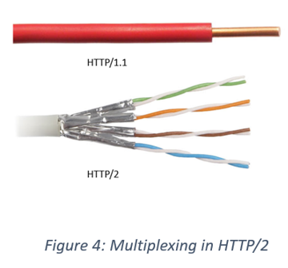

**HTTP-1.1:**

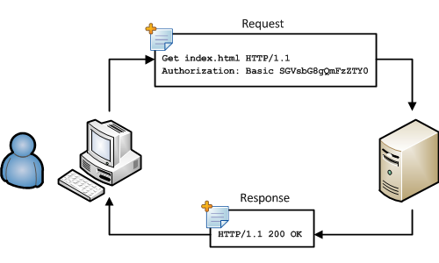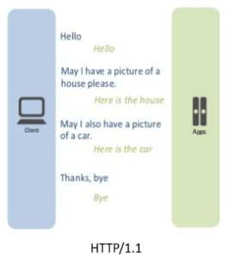For every TCP connection there could be multiple requests and responses, and pipelining where the client can request several resources from the server at once. However, pipelining was hard to implement due to issues such as head-of-line blocking and was not a feasible solution.

**HTTP-2:**

Http 2 is the new version of HTTP 1.1. The protocol introduced back in February 2015 by the Internet Engineering Task Force (IETF) Http working group.

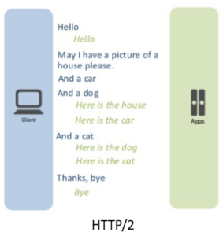The newish protocol transport data to drastically speed up the web and can help boost your [Search Engine Optimization](https://www.curvearro.com/in/locations/kolkata/).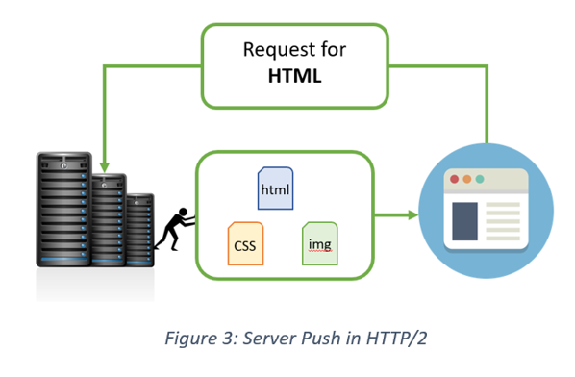 Uses multiplexing, where over a single TCP connection resources to be delivered are interleaved and arrive at the client almost at the same time. It is done using streams which can be prioritized, can have dependencies and individual flow control. It also provides a feature called server push that allows the server to send data that the client will need but has not yet requested.

#### Difference between HTTP-1.1 and HTTP-2:

|  |  |
| --- | --- |
| **HTTP - 1.1** | **HTTP - 2** |
| HTTP1 loads a single request for every TCP connection | HTTP2 avoids network delay by using multiplexing |
| HTTP/1.1 provides faster delivery of web pages and reduces web traffic as compared to HTTP/1.0. However, TCP starts slowly and with domain sharding (resources can be downloaded simultaneously by using multiple domains), connection reuse and pipelining, there is an increased risk of network congestion. | HTTP/2 utilizes multiplexing and server push to effectively reduce the page load time by a greater margin along with being less sensitive to network delays. |
| Introduces a warning header field to carry additional information about the status of a message. Can define 24 status codes, error reporting is quicker and more efficient. | Underlying semantics of HTTP such as headers, status codes remains the same. |
| Expands on the caching support by using additional headers like cache-control, conditional headers like If-Match and by using entity tags. | HTTP/2 does not change much in terms of caching. With the server push feature if the client finds the resources are already present in the cache, it can cancel the pushed stream. |
| It is relatively secure since it uses digest authentication, NTLM authentication. | Security concerns from previous versions will continue to be seen in HTTP/2. However, it is better equipped to deal with them due to new TLS features like connection error of type Inadequate_Security. |